Step 0 Intake + Interview Filing Status, Dependency

Interview Notes: (See also: General Notes)
- Andrea paid $1,000.00/month rent for the tax year.

Documents:

Step 1 Basic Information

TP Form / Note | TS Screen | Notes
SS Card | Start a New 2017 Tax Return  Available Taxpayer Profiles | Ignore the Profiles  Select “Enter Social Security Number” at the bottom of the screen  Enter the TP SSN twice and “Start Return”
 | Basic Information – Filing Status
Intake Sheet | What is your filing Status? | Answer: Filing Status: Single  Continue
SS Card  Intake Sheet  G-Note 2 | Personal Information  Taxpayer Information  Address & Phone Number | TS: Enter all information using “Caps Lock”  Hint: Use Name and SSN from SS card. (Not Intake Sheet)  Hint: SSN format YYY-00-0752  TS: Birth date can be entered using drop down menu or filling in the field.  TS: Check any of the “Check here” questions that apply –  TS: Enter Zip code- TaxSlayer fills in city and state. Correct if required  TS: Enter New Jersey as the Resident State  TS: Select Continue
Intake Sheet  G-Note 3 | New Jersey Return | Hint: Begin NJ Checklist  TS: Select Municipality from drop down menu (Listed by county). Start typing Bergen to quickly scroll down. Select Edgewater Boro.  TS: Select Yes or No for the Gubernatorial Election Fund. See Intake Sheet page 3 and General Note 3. Answer: No for TP,  TS: Five Digit Pin for TP is automatically selected  TS: Select Continue
 | Dependents or Qualifying Person  Do you have any Dependents or Qualifying Person(s) to claim on your return? | TS: Answer is “No”

Federal AGI: 0 Federal Refund: 0 NJ Refund Amount: 0

Step 2 W-2 Billings Market

W-2  Billings Market | Left Menu – Federal Section  Income  Wages & Salaries Form W-2  Begin | Hint: Make corrections so that information matches the information on the paper W-2  Hint: Use EIN 71-9000752  Hint: If the name and address of the employer come up after inputting the employer Identification Number, check that the information is correct  Hint: Always round up for amounts ending in --.50  Hint: Box 14 NJ Codes are selected from drop down menu. All other entries in box 14 are lumped under “Other”  Hint: If NJ State EIN auto populates, check to be sure it is correct  TS: Click continue NJ warning  TS: Click Continue
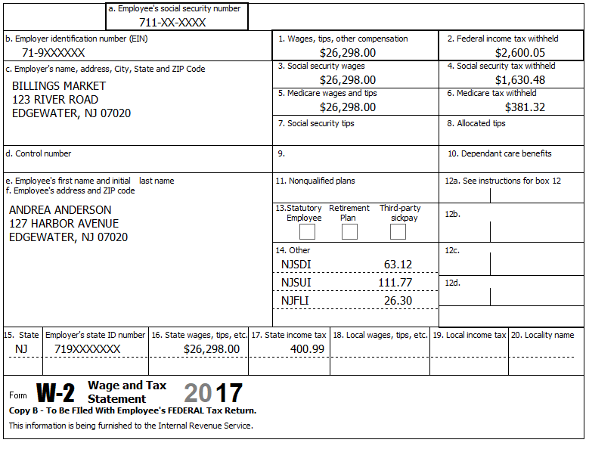

Federal AGI: 26,298 Federal Refund: 685 NJ Refund Amount: 29

Step 3 Interest 1099-INT

TP Form / Note | TS Screen | Notes
1099-INT  Big City Bank | Income  Interest and Dividends Form 1099-INT/ 1099-DIV- Begin  Interest or Dividend Income -Begin  Interest Income, Form 1099-INT,Form 1099-OID…..  Continue | Enter values that apply  Continue –

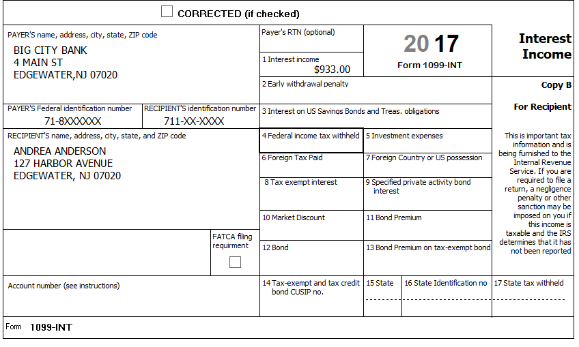

Federal AGI: 27,231 Federal Refund: 542 NJ Refund Amount: 12
Step 4 Federal Deductions, Adjustments & Credits
TP Form / Note | TS Screen | Notes
 | Left Menu – Federal Section  Deductions  Enter Myself  Itemized Deductions – Begin  Taxes You Paid - Begin | TS: Go to the Sales Tax Worksheet and enter NJ, Zip Code, and 365 days living in the state  Continue back to Deductions

Federal AGI: 27,231 Federal Refund: 542 NJ Refund Amount: 12

Step 5 Compare Standard vs Itemized Deductions

TP Form / Note | TS Screen | Notes
 | Federal Section  Deductions  Enter Myself  Compare Deductions - Begin | Check to see if using itemized or standard deductions.  Itemized = 602  Std = 6,350  Hint: You can view Schedule A (Itemized Deductions) by clicking on the Print Icon next to Itemized Deductions in the Deductions Menu.  Continue

Federal AGI: 27,231 Federal Refund: 542 NJ Refund Amount: 12
Step 6 Health Insurance
TP Form / Note | TS Screen | Notes
G-Note 2 | Left Menu-Health Insurance  Start Questionnaire | Answer questions in the Health Insurance Section

Andrea had health insurance that met Minimum Essential Coverage rules for the entire year. She did not purchase it through the marketplace.
Federal AGI: 27,231 Federal Refund: 542 NJ Refund Amount: 12
Step 7 New Jersey Return

TP Form / Note | TS Screen | Notes
I-Note 1  G-Note 2,3,4 | State Return –Edit  Enter Myself  Basic Information  Begin  Credits  Begin  Property Tax/Deduction  Begin | Hint: Use the NJ Checklist to enter NJ items  HINT: Check Basic Information  SAVE  Answer questions  Hint: Use scratch pad at TP4F to determine the proper value for Property Tax Paid  Hint: Property Taxes Paid = (rent*.18) 12,000x.18= 2,160  Hint: Taxpayer meets Property Tax Eligibility Requirements  Hint: Were you a homeowner in 2017 - No  Save back to the beginning of the State Return

Andrea paid $1,000.00/month rent for the tax year.
She did not have any out-of-state purchases on which they did not pay use tax.

Federal AGI: 27,231 Federal Refund: 542 NJ Refund Amount: 62

Step 8 Prepare for e-file

Intake Sheet  G Note 5,9,  Supplemental Intake Sheet | Left Menu – e-file – | TS – Clear up any diagnostic messages (if any)  TS: Select Federal Return Type “E:file: Paper Check”  Next  TS: No entries in Fees section except for Client email address  TS – Pin numbers for e-file are automatically selected  Next  TS: Select State Refund Type “E:file: Paper Check”  Next  TS: Skip Third Party Designee Info  Next  TS: Consent to Disclose  Select the DENY line  Enter Primary Pin for TP (any 5 digit number is OK)  Enter Primary Pin Date  Next  TS – Questions – Answer questions from Intake sheet Part VII, lines 5.6 and 7  Next  TS: Skip TP ID Information Screen  Save  You are Done.

She wants to handle any state refund / amount due like their federal refund / amount due.

Federal AGI: 27,231 Federal Refund: 542 NJ Refund Amount: 62

